***NAME : Himanshu Dixit***

***ENROLL NO. : B64178***

***BATCH : B10***

***Software Development Fundamentals – I(15B11CI111)***

***ODD 2021***

***Tutorial Sheet – 11***

***Q1.*** *Write a function that takes one string argument and returns a reversed string.*

***Solution :***

#include <stdio.h>

#include <string.h>

char *reverse(char *r);

int main()

{

char str[100];

printf("Enter any string: ");

gets(str);

printf("\nOriginal string = %s\n", str);

printf("Reverse string = %s\n", reverse(str));

return 0;

}

char *reverse(char *r)

{

for(int i=0;i<strlen(r)/2;i++)

{

char k = *(r+i);

*(r+i) = *(r+(strlen(r)-1)-i);

*(r+(strlen(r)-1)-i) = k;

}

return r;

}

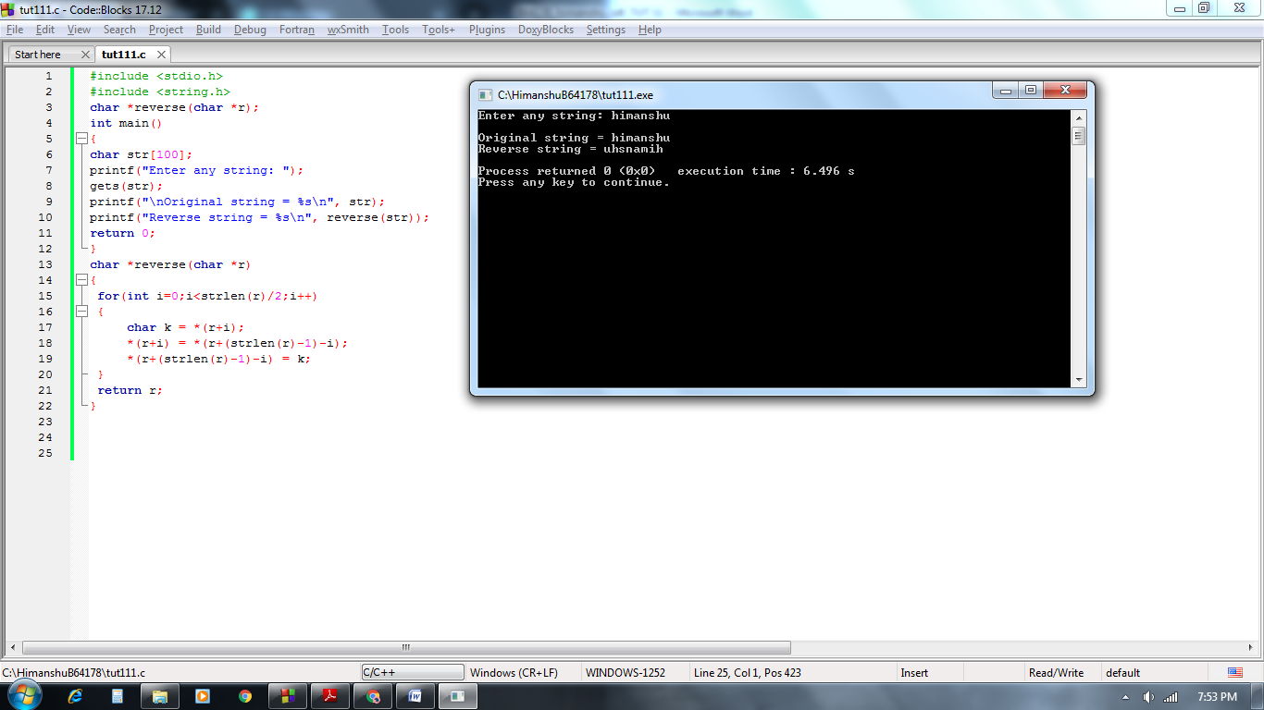

***Q2.***  *Write a function that takes one string argument and returns 1 if the given string is a palindrome otherwise returns 0.*

***Solution :***

*#include <stdio.h>*

*#include <string.h>*

*int reverse(char *r);*

*int main()*

*{*

*char str[100];*

*printf("Enter any string: ");*

*gets(str);*

*printf("\nOriginal string = %s\n", str);*

*int n=reverse(str);*

*if(n==1)*

*printf("\nstring is palindrome");*

*else*

*printf("\nstring is not palindrome");*

*return 0;*

*}*

*int reverse(char *r)*

*{*

*char *a;*

*strcpy(a,r);*

*for(int i=0;i<strlen(r)/2;i++)*

*{*

*char k = *(r+i);*

*\*(r+i) = *(r+(strlen(r)-1)-i);*

*\*(r+(strlen(r)-1)-i) = k;*

*}*

*printf("Reverse string = %s\n", r);*

*return (strcmp(a,r));*

*}*

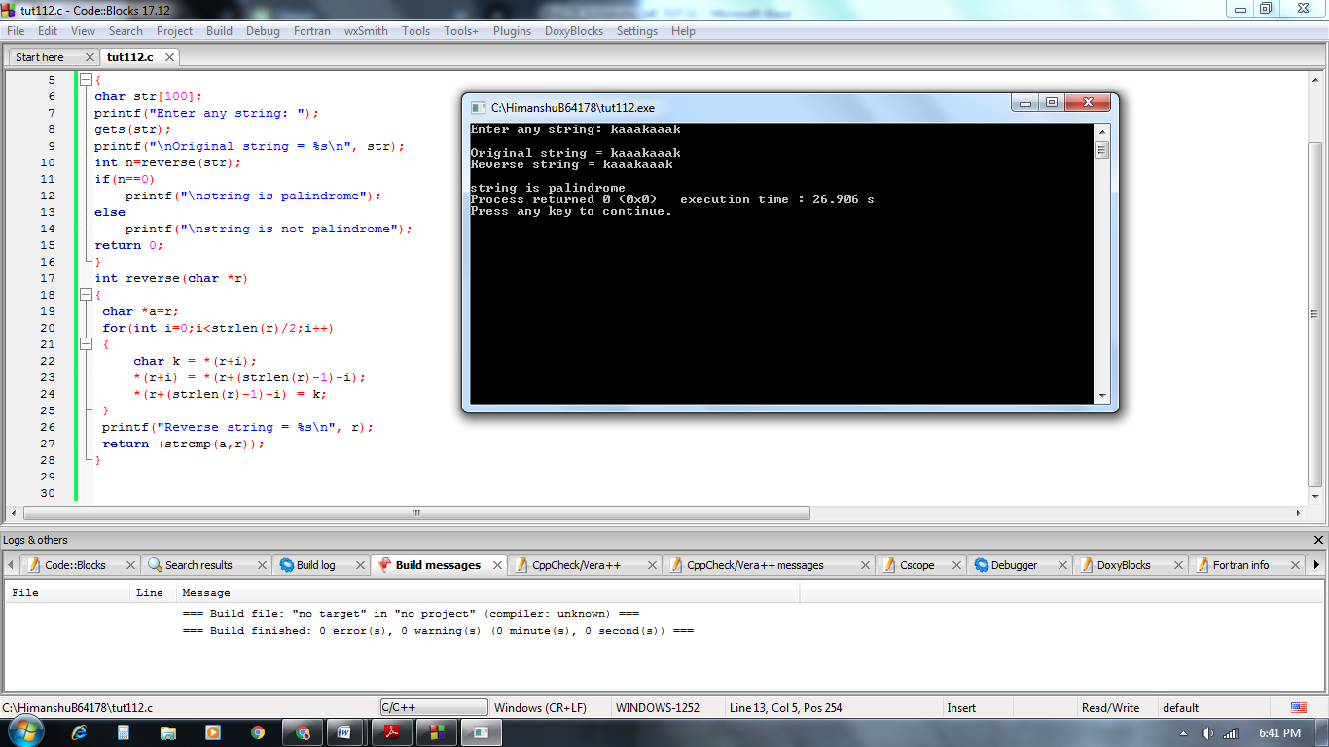

***Q3.*** *Write a function that takes two string arguments and return the concatenated string. You may use inbuilt function.*

***Solution :***

*#include <stdio.h>*

*#include <string.h>*

*int main()*

*{*

*char a[100], b[100];*

*printf("Enter first string: ");*

*gets(a);*

*printf("Enter second string: ");*

*gets(b);*

*strcat(a, b);*

*printf("Concatenated string = %s", a);*

*return 0;*

*}*

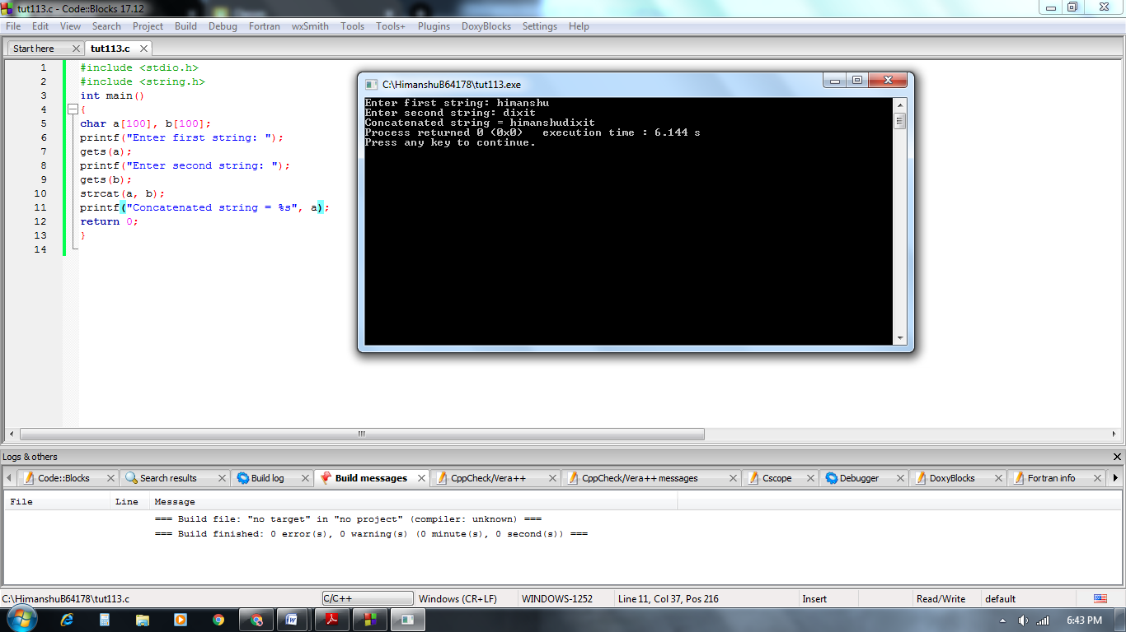

***Q4.*** *Suppose 7 names are stored in an array of pointers names[] as shown below: Char  *names []={ ‘’Anand’’ , ‘’Naureen’’, ‘’Banjot’’, ‘’Wahid’’, ‘’Sheena’’}; WAP to reverse the order of these names.*

***Solution :***

*#include <stdio.h>*

*#include <string.h>*

*void PrintArray(char* arr[])*

*{*

*for (int i = 0; i< 7; i++) {*

*printf("%s ", arr[i]);*

*}*

*}*

*void ReverseArray(char* arr[])*

*{*

*char* temp;*

*int j=6;*

*for (int i = 0; i<=j/2; i++) {*

*temp = arr[i];*

*arr[i] = arr[j];*

*arr[j] = temp;*

*j--;*

*}*

*}*

*int main()*

*{*

*char* arr[] = {"Anaand","Naureen","Banjot","Wahid","Sheena","Ali","Simran"};*

*PrintArray(arr);*

*printf("\n");*

*ReverseArray(arr);*

*PrintArray(arr);*

*return 0;*

*}*

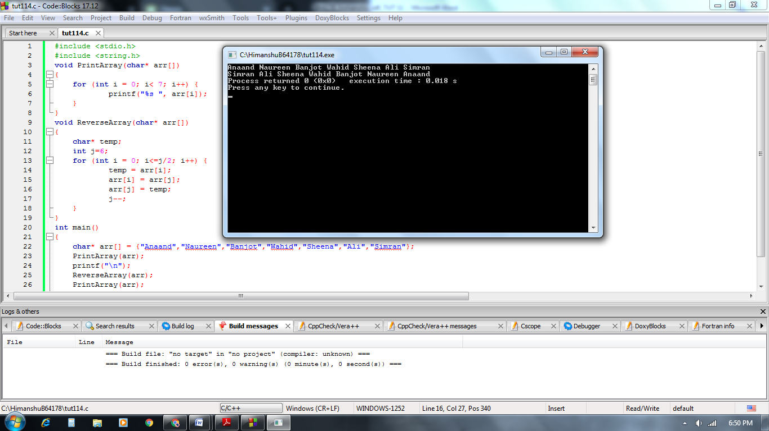

***Q5.*** *Write a menu driven program through functions using pointer for performing following operations on strings. Do not use any inbuilt function.*

*(a) Compute the length of string and print it in main function.*

*(b) Display a string in reverse order.*

*(c) Concatenate two strings.*

*(d) Copy contents of one string to another string.*

*(e)  Compare two strings.*

***Solution :***

*#include <stdio.h>*

*#include <stdlib.h>*

*int string_length(char *s)*

*{*

*int l = 0;*

*while(*s){*

*l++;*

*s++;*

*}*

*return l;*

*}*

*void reverse_string(char *s, int l)*

*{*

*for (int i = 0; i<l/2; i++)*

*{*

*int temp = *(s+i);*

*\*(s+i) = *(s+l-1-i);*

*\*(s+l-1-i) = temp;*

*}*

*printf("Reverse string is %s",s);*

*}*

*void concatinate(char *s1,char *s2)*

*{*

*int l=string_length(s1);*

*while(*s2){*

*\*(s1 +l)=*s2;*

*l++;*

*s2++;*

*}*

*\*(s1 +l)='\0';*

*printf("String 1 after concatenate is %s",s1);*

*}*

*void copy_string(char *t, char *s)*

*{*

*int i=0;*

*while(*(t+i)!='\0'){*

*\*(s+i) = *(t+i);*

*i++;*

*}*

*\*(s+i) = '\0';*

*printf("String after copy : \nstring 1 : %s\nstring 2 : %s",t,s);*

*}*

*void compare_string(char *f, char *s)*

*{*

*while(*f==*s){*

*if(*f == '\0' && *s== '\0')*

*{*

*printf("Strings are equal.");*

*exit(0);*

*}*

*if(*f == '\0' && *s== '\0')*

*break;*

*f++;*

*s++;*

*}*

*printf("Strings are not equal.");*

*}*

*int main()*

*{*

*int n,k;*

*char b[100],c[100];*

*printf("1. Compute the length of string\n2. Display a string in reverse order\n3. Concatenate two strings\n4. Copy contents of one string to another string\n5. Compare two strings\n\nEnter your choice : ");*

*scanf("%d",&n);*

*fflush(stdin);*

*switch(n)*

*{*

*case 1:*

*printf("Enter the string : ");*

*gets(b);*

*int k=string_length(b);*

*printf("Its length is : %d",k);*

*break;*

*case 2:*

*printf("Enter the string : ");*

*gets(b);*

*k=string_length(b);*

*reverse_string(b,k);*

*break;*

*case 3:*

*printf("Enter the string 1 : ");*

*gets(b);*

*printf("Enter the string 2 : ");*

*gets(c);*

*concatinate(b,c);*

*break;*

*case 4:*

*printf("Enter the string 1 : ");*

*gets(b);*

*printf("Enter the string 2 : ");*

*gets(c);*

*copy_string(b,c);*

*break;*

*case 5:*

*printf("Enter the string 1 : ");*

*gets(b);*

*printf("Enter the string 2 : ");*

*gets(c);*

*compare_string(b,c);*

*break;*

*default : printf("Invalid choice!!!!");*

*}*

*return 0;*

*}*

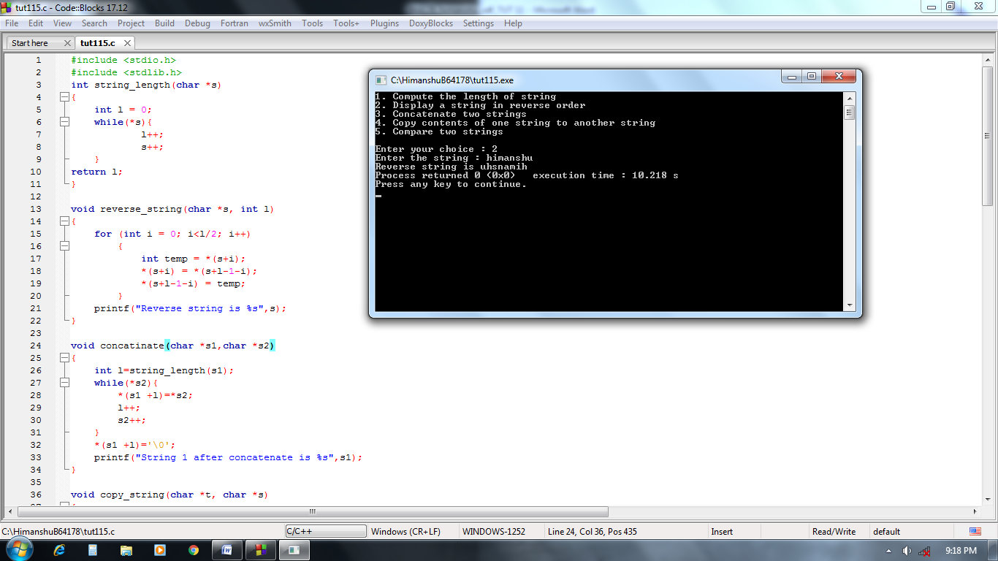

***Q6.*** *Write a C program using pointers representation of 2D array, to find the product of two matrices A and B. Display the source matrices and product matrix C in matrix format.*

***Solution :***

*#include <stdio.h>*

*void matrixMultiply(int m1[100][100], int m2[100][100], int r1, int c1, int r2, int c2){*

*int c[100][100];*

*if(c1==r2){*

*for (int i=0; i<r1; i++){*

*for (int j=0; j<c2; j++){*

*\*(*(c + i) + j) = 0;*

*for (int k=0; k<c1; k++){*

*\*(*(c + i) + j) += (*(*(m1 + i) + k)) * (*(*(m2 + k) + j));*

*}*

*}*

*}*

*printf("\nMultiplication after multiply is : \n");*

*for (int i=0; i<r1; i++){*

*for (int j=0; j<c2; j++){*

*printf("%d ",*(*(c + i) + j));*

*}*

*printf("\n");*

*}*

*}*

*else*

*{*

*printf("\nMultiplication is not possible");*

*}*

*}*

*int main()*

*{*

*int m1[100][100],m2[100][100];*

*int r1,c1,r2,c2;*

*printf("Enter row and coloumn of first matrix : ");*

*scanf("%d%d",&r1,&c1);*

*printf("Enter matrix 1\n");*

*for (int i=0; i<r1; i++)*

*{*

*for (int j=0; j<c1; j++)*

*{*

*scanf("%d",(*(m1 + i) + j));*

*}*

*}*

*printf("Enter row and coloumn of second matrix : ");*

*scanf("%d%d",&r2,&c2);*

*printf("Enter matrix 2\n");*

*for (int i=0; i<r2; i++)*

*{*

*for (int j=0; j<c2; j++)*

*{*

*scanf("%d",(*(m2 + i) + j));*

*}*

*}*

*printf("matrix 1 is :\n");*

*for (int i=0; i<r1; i++)*

*{*

*for (int j=0; j<c1; j++)*

*{*

*printf("%d ",*(*(m1 + i) + j));*

*}*

*printf("\n");*

*}*

*printf("matrix 2 is :\n");*

*for (int i=0; i<r2; i++)*

*{*

*for (int j=0; j<c2; j++)*

*{*

*printf("%d ",*(*(m2 + i) + j));*

*}*

*printf("\n");*

*}*

*matrixMultiply(m1, m2, r1, c1, r2, c2);*

*return 0;*

*}*

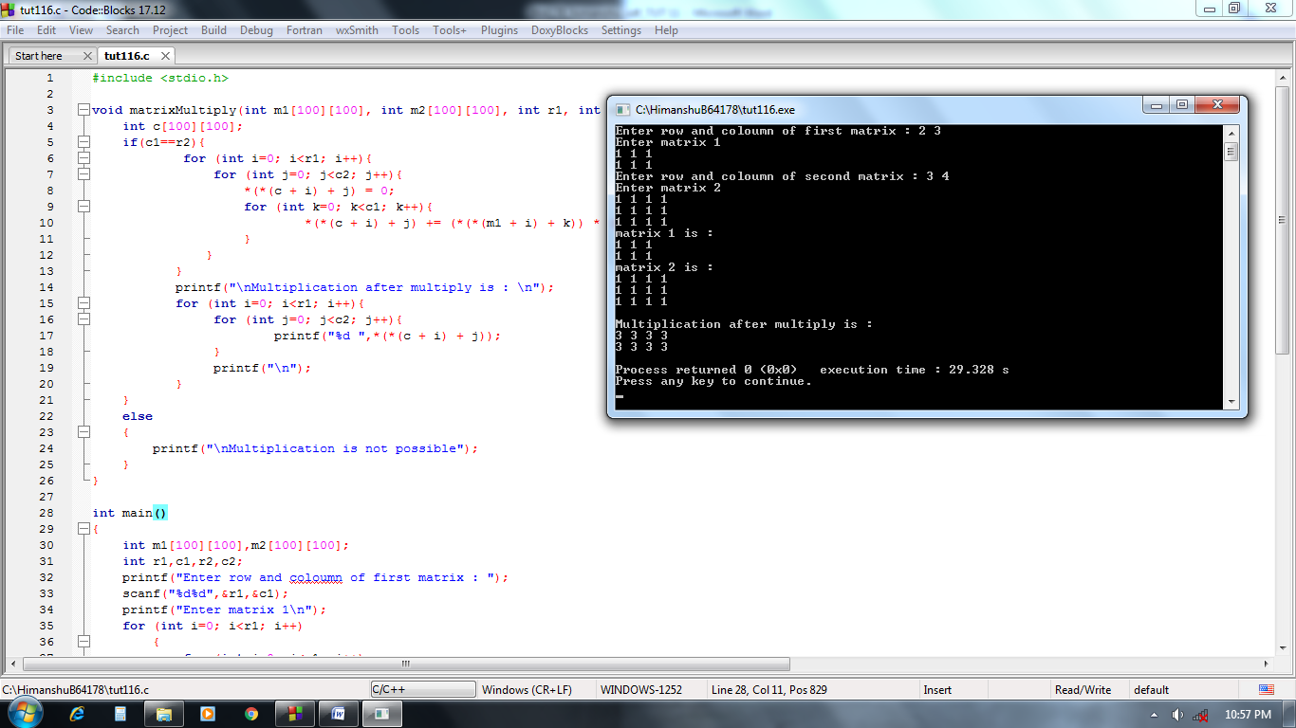

***Q7.***

***a)*** *int main()*

*{*

*int i, a[] = {2, 4, 6, 8, 10};*

*change(a, 5);*

*for(i=0; i<=4; i++)*

*printf("%d, ", a[i]);*

*return 0;*

*}*

*void change(int *b, int n)*

*{*

*int i;*

*for(i=0; i<n; i++)*

*\*(b+1) = *(b+i)+5;*

*}*

***Solution :***

*2, 15, 6, 8, 10*

***b)*** *int main()*

*{*

*int arr[] = {12, 13, 14, 15, 16};*

*printf("%d, %d, %d\n", sizeof(arr), sizeof(*arr), sizeof(arr[0]));*

*return 0;*

*}*

***Solution :***

*20, 4, 4*

***c)*** *void fun(void *p);*

*int i;*

*int main()*

*{*

*void *vptr;*

*vptr = &i;*

*fun(vptr);*

*return 0;*

*}*

*void fun(void *p)*

*{*

*int **q;*

*q = (int**)&p;*

*printf("%d\n", **q);*

*}*

***Solution :***

*0*

***d)*** *power(int**);*

*int main()*

*{*

*int a=5, *aa; /* Address of 'a' is 1000 */*

*aa = &a;*

*a = power(&aa);*

*printf("%d\n", a);*

*return 0;*

*}*

*power(int **ptr)*

*{*

*int b;*

*b = **ptr***ptr;*

*return (b);*

*}*

***Solution :***

*25*